

CPE 301 – Final Project Report
By Daniel Garcia and Joaquin Salazar
December 10, 2025

Project Description
This project's goal was to use the Arduino Mega 2560 platform to design and build an embedded system-based evaporative cooling system, also known as a swamp cooler. An energy-efficient substitute for conventional air conditioning systems, evaporative coolers work especially well in hot, dry climates. Warm air is drawn through a water-soaked medium, where evaporation cools the air before it is circulated.
In order to control cooling behavior, our swamp cooler system functions as a fully integrated embedded control system that constantly communicates with user inputs and environmental sensors. The DHT11 sensor periodically gathers temperature and humidity data, which are then shown on the LCD to give the user real-time environmental feedback. In order to prevent inefficient or dangerous operation, the water level detection sensor simultaneously keeps an eye on the reservoir to make sure there is enough water available for evaporative cooling. If the water level falls below a predetermined threshold, the system instantly turns off the fan.
The cooler can move predictably between DISABLED, IDLE, RUNNING, and ERROR states because the system logic is structured as a finite state machine (FSM). Specific system behavior, such as which sensors are active, whether the fan motor is turned on, and which visual indicators (LEDs) are illuminated, is defined by each state. Buttons and controls, such as an interrupt-driven start button that guarantees responsive transitions from the DISABLED state, are used to handle user interaction.
A DS1307 real-time clock module is used to produce precise time stamps for crucial events like state transitions and motor activation or deactivation in order to improve reliability and traceability. For logging and verification, these time-stamped events are sent via serial communication to a host computer. Real-time sensor monitoring, motor actuation, state-based control logic, and time-aware event reporting all work together to create a swamp cooler system that is reliable, safe, and meets all project requirements.

Component Details
The system's central controller is the Arduino Mega 2560. It controls serial communication, motor control, state transitions, sensor readings, and LCD output. To adhere to project constraints, direct register manipulation was utilized for GPIO, ADC, timers, and UART functionality. Real-time temperature and humidity readings, system status messages, and error alerts are displayed by the LCD 1602 module. During regular operation, the display updates once every minute, giving the user ongoing feedback. The fan motor and other parts were safely powered by a specialized power supply module. This shields the Arduino Mega's output circuitry and guarantees dependable motor operation by preventing excessive current draw. The reservoir's water level is tracked by the water level detection sensor. The system enters the ERROR state when the water level drops below a predetermined threshold. This safeguards the system and keeps the cooling system operating properly by preventing the fan motor from operating without enough water. The current date and time are recorded by the DS1307 RTC module. Time-stamped events, like state transitions and motor activation/deactivation, are recorded and sent to a host computer via a serial interface. The DHT11 sensor provides ambient temperature and humidity readings. These measurements are used to determine when the system should transition between IDLE and RUNNING states and are continuously displayed on the LCD during operation. Air circulation is handled by the DC motor and the attached fan blade. In the RUNNING state, the motor is turned on; in the ERROR and DISABLED states, it is turned off.

Libraries Used
When specifically permitted by the project guidelines, the following libraries were used: The DHT11 temperature and humidity sensor is interfaced with using DHT.h. Reading environmental data needed for state transitions is made easier with this library. Wire.h allows the Arduino Mega 2560 and the DS1307 real-time clock (RTC) module to communicate via I2C. RTClib.h offers high-level access to the DS1307 RTC, enabling precise date and time retrieval for event recording. LiquidCrystal.h controls the LCD 1602 display, which shows the user error messages, temperature, and humidity. The 28BYJ-48 stepper motor, which modifies the vent direction in response to potentiometer input, is controlled by Stepper.h. According to course limitations, direct register manipulation is used for all other hardware interactions, such as GPIO, ADC, UART, and motor control.

Code Operates
The swamp cooler system's basic logic is contained in the main.cpp file. It reads sensor data, processes user input, initializes all peripherals, and uses a finite state machine (FSM) to regulate system behavior. Hardware Configuration and Initialization. GPIO registers are manually configured to specify input and output pins for buttons, LEDs, and the motor driver in the setup() function. To enable serial data transmission without the need for Arduino's Serial library, UART communication is initialized using U0Init(9600). To read the water level sensor, the ADC subsystem is initialized using adc_init(). The corresponding libraries are used to initialize the DHT11 sensor, RTC module, LCD, and stepper motor. To ensure accurate timestamps throughout operation, the RTC is checked at startup and automatically adjusted if it is not operating. There are two buttons used a reset button to get out of the ERROR state and a toggle button to turn the system on or off Reliable button press detection is ensured by a software debounce mechanism that uses millis() and reads button inputs directly from hardware registers.
Vent position is adjust using the stepper motor. We made a moveVent() function which controls the stepper motor based on the position of a potentiometer. It reads an analog input value, clamps readings near the minimum and maximum limits to prevent instability at the mechanical end stops, and converts the input into a corresponding stepper motor position. A deadband is applied to ignore small input changes and eliminate unnecessary motor movement. The function tracks the previous motor position and only commands the stepper to move when a significant change is detected, ensuring smooth, stable, and efficient vent positioning.
Four coordinated states govern the system's operation, monitoring, and safety. When the system is in the DISABLED state, a yellow LED is lit, the fan motor is off, sensor monitoring is not active, stepper motor is off, and it waits for the user to activate the system. When activated, the system goes into the IDLE state, continuously monitoring the water level with the fan off, stepper motor on, and a green LED on while displaying temperature and humidity on the LCD. The system switches to RUNNING, where the fan circulates air, the vent position is constantly adjusted, and a blue LED indicates activity, if the temperature rises above its threshold. The system goes into the ERROR state when the water level drops below its limit. In this state, the fan is forced off, stepper motor still on, a red LED is illuminated, an error message is displayed, and the system stays locked until it is restored.
In order to comply with project limitations, the serial.cpp/serial.h module implements low-level UART communication using direct register access rather than Arduino's Serial library. It offers utility functions like putChar(), putString(), and putInt() to send formatted data and sets up the baud rate, data framing, and transmitter and receiver operation. For logging and debugging purposes, this module transmits timestamps and system events to a host computer. The microcontroller's ADC hardware, which is manually configured through registers, is used in the watersensor.cpp/watersensor.h module to implement water level detection. The right input channel is chosen, the ADC is turned on with AVCC as the reference, and conversions are initiated and polled until they are finished. In order to identify system state transitions under both normal and fault operating conditions, the resulting 10-bit value is returned and compared against a predetermined threshold.

Schematic Diagram:
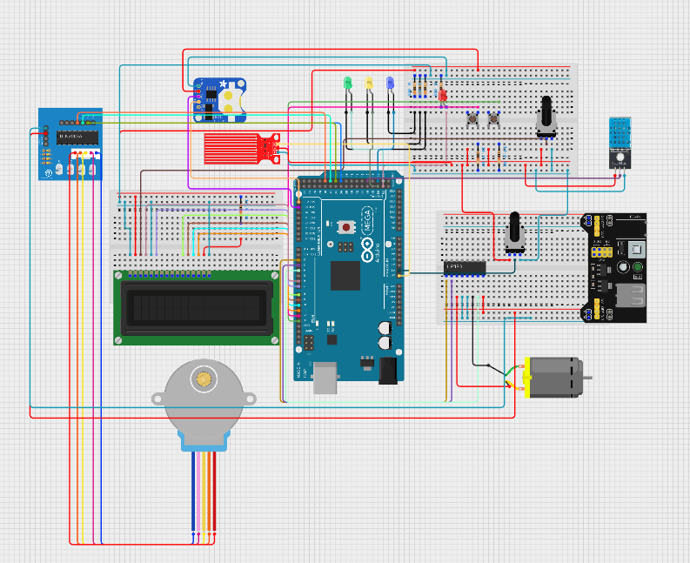

Circuit Image:
